SMART SHOPPING CART

USING ARDUINO

**Project Title: Smart shopping cart using arduino**

**DSD(CSE461) Project**

**Group No: 07**

|  |  |  |
| --- | --- | --- |
| Name | Student ID | Section |
| Samin Azhan | 14101005 | 02 |
| Anik Zaman | 13201052 | 02 |
| Tahmid Abdullah | 14101142 | 02 |
| Seevieta Biswas Toa | 14101003 | 02 |

**Table Of contents**

Introduction…………………………………………………………………………………...4

Motivation.……………………………………………………………………………………4

Equipment.……………………………………………………………………………………5

Hardware.……………………………………………………………………………………..5

Software.……………………………………………………………………………………...6

Set-up.………………………………………………………………………………………...6

Working Procedure.…………………………………………………………………………..6

Experimental Results.………………………………………………………………………....7

Conclusion and future works.…………………………………………………………………7

Acknowledgements.…………………………………………………………………………..7

References.……………………………………………………………………………………8

**Introduction**

In modern world, many industries are innovating and developing products that guarantee the convenience of people. One of the appliances that involved will be providing with new, easy and time saving shopping experience. With the astounding development of electronics and by the tweak of robotics many people are developing machines that can ease the human life. Like all other enthusiasts, we were also inspired by the idea of robotics and decided to make a machine that can provide a better shopping experience and save valuable time of the shoppers. Thus the idea of developing a “Smart Shopping Cart” came up.

There are many projects now based on the idea of smart shopping cart. Companies like Walmart, Panasonic, Amazon etc. are developing their own automated shopping cart system which are also based on the similar idea with some small differences. All these projects are little too complicated for beginners of robotics and costly for a third world country like Bangladesh to be implemented in many shopping malls at the very least. So, we as a group wanted to develop this whole project in our own way in the cheapest and the most effective way possible which has the potentiality of expansion in the future.

We as a team believe that the smart shopping cart system will be more reliable, convenient, easy and time saving when it comes to shopping because customers don’t have to walk through the aisle to find out the products and wait in a long queue at the checkout counter.

**Motivation**

The dream of our team was to make such a device which ensures saving the valuable time of the shop goers and save them from the hassle of waiting in the queue for checkout counter. To accomplish that goal, the team has developed “Smart Shopping Cart” using Arduino Uno. We chose this project because it has real life applications and makes our day to day life very convenient. So, the idea of making a Smart Shopping Cart seemed like a perfect step towards our goal. Any supermarket can implement this idea to increase their sales and make their customers happy with their service. The components we used to make a prototype of this project couldn’t be more cost effective. To make it cheaper we used Arduino instead of Raspberry pi.

**Equipments**

1. Sonar sensor
2. Arduino Uno (x2)
3. DC Motor Shield
4. Three wire LCD display
5. Arduino Bluetooth module
6. Android phone
7. 5 Volt Battery
8. Breadboard
9. LEDs
10. Switches
11. Wire

**Detail information of the equipments:**

**Sonar Sensor:** A device that can measure the distance to an object by using sound waves. It sends out high frequency sound pulse and measures time of the reflected echo. Used in the cart to avoid collision with something on its way.

**Arduino uno:** A microcontroller board based on the ATmega328. It has 14 digital input/output pins of which 6 can be used as PWM outputs, 6 analog inputs, a 16MHz ceramic resonator, a USB connection, a power jack, an ICSP header, and a reset button.

**Motor shield:** a dual full-bridge driver designed to drive inductive loads such as relays, solenoids, DC and stepping motors. It drive can two DC motors with the Arduino board, controlling the speed and direction of each one independently.

**Bluetooth module:** connects to a device and the serial monitor could be opened to watch the received data at the time of connection. In our project, to scan the products an android barcode scanner was used. To transfer the data of the scanned products, Bluetooth module was needed.

**Breadboard:** A breadboard is used to build and test circuits quickly. The breadboard has many holes into which circuit components like ICs and resistors can be inserted.

**LED:** A light-emitting diode (LED) is a semiconductor device that emits visible light when an electric current passes through it.

**Switches:** An electrical switch is any device used to interrupt the flow of electrons in a circuit. Used to select the products in our project.

**Wires:** Used to connect components or devices.

**Set-up**

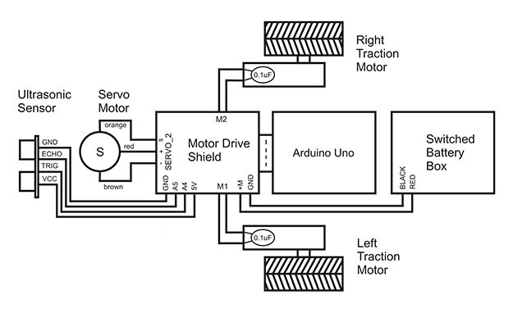

**Working Procedure**

The shopping cart is powered by two arduino uno. One for controlling the motor drivers, which will make the cart move inside the shopping mall. And another one, to control the inputs given by customers via several switches. For our demo model, we used 3 demo products and for them used 3 switches to select those products. After the input is given, the cart to will move into the shop and wait after reaching product counter. A shopkeeper then scans the items via a barcode scanner app implemented in android. After selection, the cart will automatically move forward and turn if any obstacle is sensed via sonar sensor and the cart will move outside to the mall.

**Experimental Results**

Everything is working accordingly. Although at times, it takes some time to load the inputs. Another drawback is that, because of weight imbalance, the cart sometimes doesn’t move in the direction that we intended for. As we couldn’t find any barcode scanner that supports Arduino, we had to make our own with an android phone. Depending on phone camera quality, it sometimes is difficult to read the barcodes.

**Conclusion**

The hassle of going to a shopping mall and searching through the products is almost over. The proposed smart cart will save time and energy of the customer. No jobs of the shopkeepers will be taken away as they will help the cart to find the products and also scan them. In the future, smart cart can be interfaced with wireless technologies to make it completely portable. Payment of bills using mobile phones can also be implemented.

**Acknowledgement**

We would like to express our special thanks of gratitude to lab instructors Masuma Akhter Rumi, Lecturer, Department of Computer Science & Engineering as well as our course instructor Dr. Md. Khalilur Rahman, Associate Professor, Department of Computer Science & Engineering for giving us the opportunity to work on this project and providing assistance and necessary guidance that helped us complete the project and learn many new things in the process.

**Reference**

1. <https://wingoodharry.wordpress.com/2014/03/11/simple-android-to-arduino-via-bluetooth-serial/>
2. <https://www.youtube.com/watch?v=t3kXWSctj2Q>
3. <https://www.arduino.cc/en/Reference/LiquidCrystal>
4. <https://www.arduino.cc/en/Reference/Millis>